Department of Computer & Information Sciences
ASSESSMENT BRIEF
Module Title: | Advanced Databases
Module Code: | KL7011
Academic Year / Semester: | 2025-256 / Semester 1
Module Tutor / Email (all queries): | Akhtar Ali akhtar.ali@northumbria.ac.uk
% Weighting (to overall module): | 60%
Assessment Title: | Assignment 1: individual work
Date of Handout to Students: | 20th October 2025
Mechanism for Handout: | Module Blackboard Site
Deadline for Submission Attempt by Students: | Thu 27/11/2025 @ 16:00 GMT
Mechanism for Submission: | Document upload to Module Blackboard Site
Submission Format / Word Count | Please upload your written report as a single PDF document
Date by which Work, Feedback and Marks will be returned: | 31st December 2025
Mechanism for return of Feedback and Marks: | Mark and individual written feedback will be uploaded to the Module Site on Blackboard. For further queries please email module tutor.

LEARNING OUTCOMES
The learning outcomes (LOs) for this module are:-
LO1 You will be able to demonstrate critical understanding of the entire data life cycle and classical database engineering processes and approaches, and non-traditional database systems.
LO2 You will be able to demonstrate deep knowledge of key concepts of data warehousing, data analytics, data standards, and data quality.
LO3 You will be able to critically analyse, select, apply and evaluate advanced data modelling, database design, implementation and manipulation methods, techniques and tools to a complex data management problem and explore, recognise and appreciate opportunities for innovation.
LO4 You will be able to Appraise, analyse, design, develop and evaluate data warehousing and data analytics solutions using Oracle database system and evaluate their environmental and societal impact and minimise their undesirable impact.
LO5 Develop critical awareness of the responsibilities of database developer with respect to sustainability, professional, legal, security and ethical issues, become aware of applicable health & safety, diversity, inclusion, cultural, societal and environmental matters as well as undertake risk management and evaluation of commercial risk in relation to data management, individually or as part of a team based on critical review of current literature, systems, developments, and standards.

This assessment addresses learning outcomes LO1, LO3 and LO5.

Instructions on Assessment:

- You are expected to produce a word-processed answer to this assignment. Please use Arial font and a font size of 12 for text. For SQL code and output, you can use courier new font and a minimum size of 10, which preserves SQL format and layout. Where necessary, screenshots of ‘SQL output’ may be used instead of plain text.
- You are required to use the Harvard Style of referencing and citation. The “Cite them right” guide is recommended for referencing and citation (Pears and Shields, 2008) which should be followed throughout your answer. Please do not include references to lecture notes.

Assessment Regulations

You are advised to read the guidance for students regarding assessment policies (Northumbria, 2025). They are available online here.

No Submission or Late submission of work

All students are required to submit their work as per the above deadline. Where coursework is submitted late without approval, after the published hand-in deadline, the following penalties will apply.

For coursework submitted up to 1 working day (24 hours) after the published hand-in deadline without approval, 10% of the total marks available for the assessment (i.e.100%) shall be deducted from the assessment mark.

Coursework submitted more than 1 day (24 hours) after the published hand-in deadline without approval will be marked as zero but will be eligible for referral.
The full policy can be found here.

Students must retain an electronic copy of this assignment (including ALL appendices) and it must be made available within 24hours of them requesting it be re-submitted.

Academic Misconduct (AM)

The Assessment Regulations for Taught Awards (ARTA) contain the Regulations and procedures applying to cheating, collusion, plagiarism and other forms of academic misconduct.

The full policy is available at here

You are reminded that plagiarism, collusion, falsification / ghosting, and other forms of academic misconduct, as referred to in the Academic Misconduct procedure of the assessment regulations, will be taken very seriously. Assignment submissions in which evidence of plagiarism or other forms of academic misconduct is found may receive a mark of zero or maximum of a pass mark if admitted by the student or otherwise proven through the AM procedure.

Generative AI, Proof Reading and Paraphrasing Tools
Northumbria University’s guidance on AI Tools / ChatGPT can be found here. Any use of generative AI tools or AI based proof reading or paraphrasing tools is not permitted in this module except the following when properly acknowledged (i.e., which tools are used and what search prompt or keywords were used):

- support with literature searching or identifying relevant sources of information
- help with formatting references and citations

The following use of AI tools or software engineering automation (SEA) tools will lead to academic misconduct investigation:
- code, data or text generated by AI & SEA tools
- diagrams or models created by AI & SEA tools either from assignment specification text or reverse engineering or mapping code to diagrams
- any data dictionary descriptions or definitions or specifications generated by AI & SEA tools

Criteria for success:

For textual components :
80-100% - The description will critically assess and cover all the LOs of the assessment. The written work will be fluent, clearly presented and of out-standing quality.
70-79% - The description will critically assess and cover almost all the LOs of the assessment. The written work will be fluent and clearly presented and of distinctive quality.
60-69% - The description will show a very good knowledge of most of the LOs of the assessment with very good presentation skills and quality.
50-59% - The student will show an above average knowledge of the LOs of the assessment with above average presentation skills and quality.
40-49% - There will be an inadequate coverage of a significant proportion of the LOs of the assessment. There will be no major failures in presentation clarity though partly inadequate.
Less than 40% - There will be little or no information conveyed in an intelligible manner on the knowledge of most of the LOs of the assessment.

For ERD/EERD, SQL and other database technical components:
80-100% - The students will produce exceptional models (conceptual/logical/physical), and will demonstrate the use of notation/language, which have outstanding syntactic accuracy (e.g., adhering to ER/EER modelling standards, error free SQL code), with exceptional semantic relevance (e.g., are relevant to the requirements of the particular scenario).
70-79% - The students will produce fully complete models (conceptual/ logical/ physical), and will demonstrate the use of notation/language, which have high syntactic accuracy, with high semantic relevance.
60-69% - The students will produce almost complete models (conceptual/ logical/ physical), and will demonstrate the use of notation/language, which have appropriate syntactic accuracy with reasonably well semantic relevance.
50-59% - The students will produce fairly complete models (conceptual/ logical/ physical), and will demonstrate the use of notation/language, which have adequate syntactic accuracy with reasonable semantic relevance.
40-49% - The students will produce models, and will demonstrate the use of notation/language, which have some syntactic accuracy and semantic relevance but on balance inadequate as a whole.
Less than 40% - The students will not produce sufficient models, and/or will be unable to demonstrate the use of notation/language with significant syntactic accuracy and/or significant semantic relevance.

Assessment Background and Scenario

This assessment is based on the scenario NORTHERNTOURS of a fictitious travel company. The company wants to develop an information system to support its business. The details of the scenario are provided in the Appendix.

Assignment Questions/Tasks

Part 1 (40 marks)
This part is based on the NORTHERNTOURS scenario as described in the Appendix.

- Using entity-relationship (ER) OR enhanced entity-relationship (EER) modelling, produce a conceptual design of the database for supporting the information system of the NORTHERNTOURS company.
(20 marks)

- Convert the ER / EER diagram from Part 1(A) to produce a logical relational schema using ER / EER to relational mapping.
(12 marks)

Points to consider while preparing your solution to this part follows.

Regarding Part 1 (A):
- The ER/EER diagram should show all relevant entity types, relationship types, key attributes, primary keys, and structural constraints.
- Not all keys are identified/mentioned in the scenario, so you are required to identify/devise appropriate primary keys for all the entity types.
- The ER/EER diagram must not show/include any foreign keys or any such attributes that represent foreign keys as these are logical and not conceptual constructs.

Regarding Part 1 (B):
- As part of the mapping process, for each relation, you should identify appropriate primary keys as well as foreign keys (if applicable). Furthermore, you need to make sure your relations obtained from mapping your ER/EER diagram are in the 3rd normal form.
- You need to research, choose, and justify an appropriate naming convention for relations, attributes, and keys. You need to use your chosen convention consistently throughout your assignment.
- You need to document all elements of your logical relational schema in a data dictionary, in a tabular form and must be presented as text rather than an image or picture. The data dictionary should include all relevant names, descriptions, and constraints.

(C) Based on your logical design from Part 1 (B) and the information available in the scenario, produce an SQL script file using Oracle 11g/12c/higher.
(8 marks)
Points to consider while preparing your solution to this part:
- Provide the SQL DDL code as text (e.g., CREATE TABLE, ALTER TABLE, etc.) statements for creating all the relations from Part 1 (B).
- Provide the output from running the script file in a live Oracle 11g/12c/19c/higher session (e.g., using SPOOL, copy and paste, screenshots, etc.). If output is missing, 2 marks will be deducted from the above 8 marks. If output is incomplete or inadequate or misleading, then adequate marks up to a max of 2 will be deducted.
- You should use relational features from the SQL92 standard in Oracle 11g/12c/higher for constructing your data structures / tables, including appropriate primary and foreign keys.
- You should aim for a high degree of reliability in the data with use of as many constraints as possible, e.g., check constraints on various columns (e.g., particular format of primary key values, positive physical values as described in the relevant lecture on integrity constraints).

Part 2 (15 marks)

This part is based on your answer / solution to Part 1 (design and implementation of the database) for the NORTHERNTOURS scenario.

(A) Populate a subset of the relations of the database with sample data for answering the queries in Par 2 (B), i.e., you should generate your own dummy data and load it into the NORTHERNTOURS database, consider 5 to 10 rows for each table in your subset and enough data to see meaningful output for the queries below.
(7 marks)

(B) Answer the following queries (retrievals) using Relational Algebra and SQL.
(8 marks)

- Display details of schedules for travelling between Newcastle and Berwick-upon-Tweed with seven or more available seats in the next 14 days.

- Display details of the travel agent(s) with the most ticket sold from 15th September to 15th October 2025.

Points to consider while preparing your solution to Part 2:
- Provide appropriate SQL DML code (e.g., INSERT) for populating the tables you have created in Part 1 (C).
- Relational Algebra expressions for Part 2 (B) (4 marks in total).
- Provide SQL queries code (e.g., SELECT) for Part 2 (B) (4 marks in total).
- Provide output for running each of above the two solutions / scripts (SQL DM Code and SQL queries) in a live Oracle 11g/12c/higher session (e.g., using SPOOL, etc.). If any of the output is missing, 2 marks will be deducted from the above. If outputs are incomplete or inadequate or misleading, then adequate marks up to a max of 4 will be deducted.

Part 3 (35 marks)

This part is based on your answer / solution to Part 1 (A), i.e., conceptual design of the database for the NORTHERNTOURS scenario.

(A) Choose and justify what aspects of NORTHERNTOURS conceptual design would be better off if implemented using object-relational database; then provide logical design and implementation of the subset of the NORTHERNTOURS using ER/EER to object-relational mapping and object-relational features of Oracle Database System (Kannan, 2019); populate the object-tables with sample data and demonstrate your choice of design and implementation by running two complex queries [e.g., having multiple joins and aggregations] on your object-tables.
(20 marks)

(B) Analyse the conceptual database design from Part 1 (A) and the NORTHERNTOURS scenario in the Appendix and propose what aspects of the NORTHERNTOURS database would benefit from incorporating NoSQL Database concepts. Discuss what design choices you made for implementing your chosen subset in NoSQL Database. Illustrate your answer with a representative code from NoSQL Database implementation.
(15 marks)

Part 4 (10 marks)

Consider the NORTHERNTOURS scenario in the Appendix. Produce a report for the managing director of the NORTHERNTOURS company – elaborating on sustainability, professional, legal, ethical and security issues, and matters related to diversity, inclusion, cultural, societal and environment as well as risk management and evaluation of commercial risks that need to be considered and make appropriate recommendations for NORTHERNTOURS. Whilst answering this question, employ a critical review of current and relevant literature, systems, developments, and standards.
(10 marks)

The report should be concise and comprehensive and in the region of 900-1000 words. You should use Harvard style of citation and referencing by following the guidelines in Pears and Shields (2008).

Hand-in procedure: You should hand in your answer for this assignment as a single word-processed document electronically on the Blackboard. A sample assignment template file will be uploaded on the Blackboard.

APPENDIX: NORTHERNTOURS Scenario

NORTHERNTOURS is an established transport company that has a fleet of luxury coaches that serves various cities, towns and popular tourist sites in and around Northern region of England. Tickets can be bought through selected tour agents throughout the North-East. Tickets are obtained on first come first serve basis. Because NORTHERNTOURS provides excellent services for the comfort of its passengers, tickets are sold very fast and have to be confirmed by NORTHERNTOURS, which issues all the ticket numbers for all tickets purchased.

Currently each agent has a paper-based inventory system. There is also a paper-based inventory system in NORTHERNTOURS. It is felt that it would be more efficient to have one computer-based system, which tracks the transactions by all agents and at the same time enable NORTHERNTOURS to carry out its tasks more efficiently.

The current paper-based system manages logistics besides transactions in the company. Firstly, there is a sales book for the tickets sold. Each agent submits a sales list(see Figure 1) at the end of the day. The sales lists from the agents are filed in the sales book each day. Tickets are provided for each route which has stops at certain cities and locations. Different routes may have different duration for each stop to cater for various customer needs. There is a need to record what sorts of meals are available at each stop. There may be several schedules for similar routes at different times each day (see Figure 2). NORTHERNTOURS constantly provides the agents with updated information on what schedules and times are available. The agent or its employees phone NORTHERNTOURS company clerks to obtain the ticket number by specifying the schedule id, or if unknown, the route id, date and time. Once the ticket is confirmed, the information is entered into the sales list.

The clerk updates the number of available seats in the schedule list (see Figure 2) whenever tickets are sold. He/she has also to inform the company manager if there are no available seats for a particular schedule. The manager may at his discretion add an available vehicle and driver to a new schedule. The clerk must phone the agents to inform them if there are any updates to the list of schedules.

On a regular basis, each agent receives updates of available routes & schedules from NORTHERNTOURS. Each information includes the schedule id, route description (which is a list of cities and stops), departure date and time, and cost which is to be maintained by the agent (see Figure 3) for serving its customers. The information is almost identical to NORTHERNTOURS’s schedule list except for the “No of Seats Left” information which does not need to be maintained by the agent. All ticket sales are via NORTHERNTOURS and the agent completes the information in the sales list.

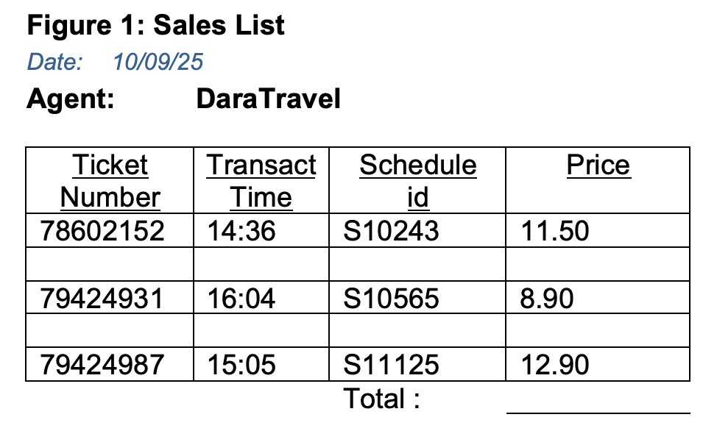

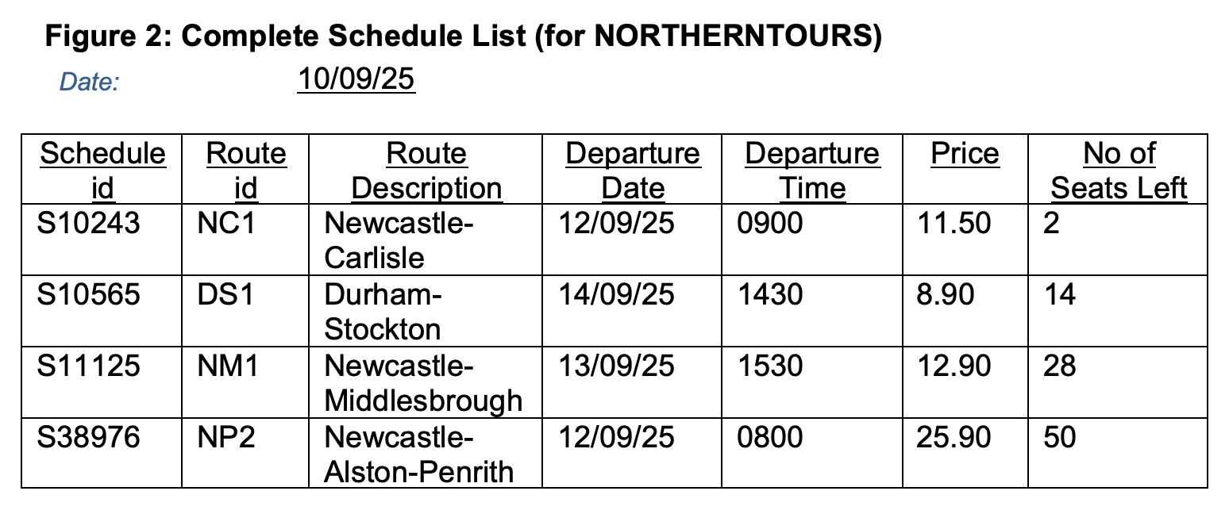

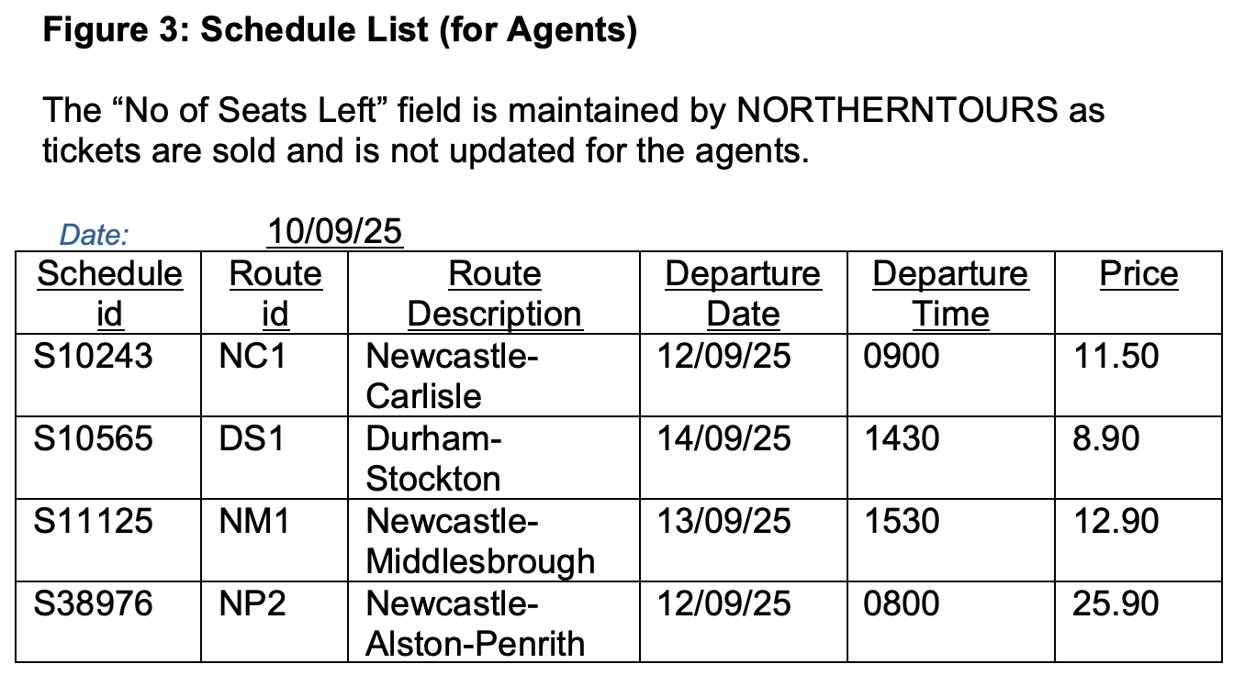

References & Bibliography

Northumbria (2025) Academic Regulations for Taught Awards (ARTA) – 2025/26. Available at: https://www.northumbria.ac.uk/about-us/university-services/student-library-and-academic-services/quality-and-teaching-excellence/assessment/assessment-regulations-and-policies/ (Accessed: 29 September 2025).

Kannan, P.K. (2019) Oracle Database Object-Relational Developer's Guide -19c. Part Number E96436-01. Available at: https://docs.oracle.com/en/database/oracle/oracle-database/19/adobj/index.html (Accessed: 29 September 2025).

Pears, R. and Shields, G. (2008) Cite them right: the essential referencing guide.
Newcastle upon Tyne: Pear Tree Books. Available at: https://www.citethemrightonline.com/ (Accessed: 29 September 2025).

